Place each of the words from the Tagul in “Initial Thoughts” into one section below. Reflect on your word placement to a peer. Would you have placed the words differently before completing the learning module?
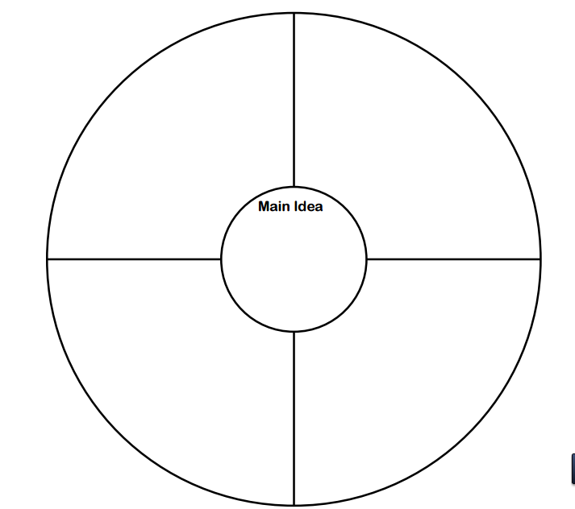
Mental Health Disorders
Autism
Mood Disorders
ODD
ADHD

